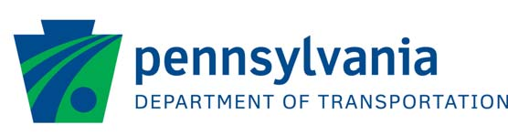
QUESTIONS/COMMENT SHEET
SR 0512 (Beth-Bath Pike) over Monocacy Creek
Bridge Replacement Project
Plans Display

June 2024
Please let us know if you have any comments, questions, or concerns regarding the SR 0512 (Beth-Bath Pike) over Monocacy Creek Bridge Replacement Project in the space below. Feel free to use the comment sheet if desired, and email or mail the form and/or any additional questions, comments or concerns to:
Mr. Michael McGuire, P.E.
Gannett Fleming, Inc.
1275 Glenlivet Drive, Suite 305
Allentown, PA 18106
Phone: 610-783-3825
c‐micmcgui@pa.gov
PLEASE RETURN BY June 30, 2024. Thank you for your interest and input!
1. Which of the following best describes you?
Resident

Business Owner

Commuter

2. What issues are most important to you regarding the bridge replacement project? (Traffic
Improvements? Construction duration? Travel Delays? etc.)

3. Do you have any suggestions or concerns about the construction phase? If so, what are they?

ADDITIONAL COMMENTS:

NAME:
ADDRESS:
PHONE: |  | EMAIL:

