

PRSRT STD

ECRWSS

U.S. POSTAGE

PAID

EDDM RETAIL

Engineering District 3-0

715 Jordan Avenue

Montoursville, PA 17754

Local

Postal Customer

**Pennsylvania Department of Transportation and EQT Production Company would like to notify you of two separate embankment stabilization projects on SR 44 in Watson and Cummings townships, Lycoming County. Please see the reverse side for project details.**

**Contact Information can be found at the PennDOT District 3 webpage – Route 44 Embankment Stabilization Project.**

[**https://rb.gy/f49p2b**](https://rb.gy/f49p2b)



**Project Overview**

**SR 44-86S and SR 44-103, Lycoming County**

The **SR (State Route) 44-86S** (PennDOT) project is a two-year embankment stabilization project between Torbert Lane and Tombs Run in Watson Township. Work on this project began in the Spring of 2024 and includes stabilizing the existing embankment using soil nailing, wire mesh, and rock armoring, throughout the project limits, which are shown in RED on the below location map. Motorists can expect single lane conditions controlled by a temporary traffic signal. Work on this project is anticipated to be completed by the fall of 2025. If you have specific questions about this project, contact Jay Miller at 570-368-4233 or by email at [jaymiller@pa.gov](mailto:jaymiller@pa.gov).

The **SR 44-103** (EQT Partnership) project is a two-year embankment stabilization project located between SR 973 in Watson Township and Waterville in Cummings Township. Work on this project is anticipated to begin in July of 2024 and includes stabilizing 18 embankment areas throughout the project limits, which are shown inRED on the below location map. Motorists can expect delays in travel due to a combination of temporary traffic signals and flagging where work is being performed. EQT is the administrator of this $9.3 million embankment stabilization project, which is anticipated to be complete by the summer of 2025. If you have specific questions about this project, contact Steve Tokarz at 570-368-4226 or by email at [stokarz@pa.gov](mailto:stokarz@pa.gov).

Both projects have an 11-foot width restriction and will have a winter shut down.

**SR 44-103 Cummings and Watson twps.**

**(EQT Partnership Project)**

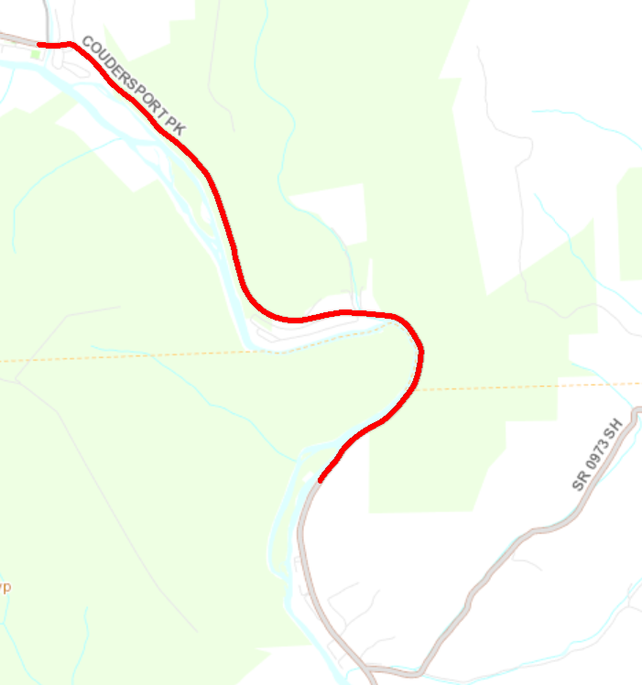

**Waterville**

**SR 973**

**SR 44**

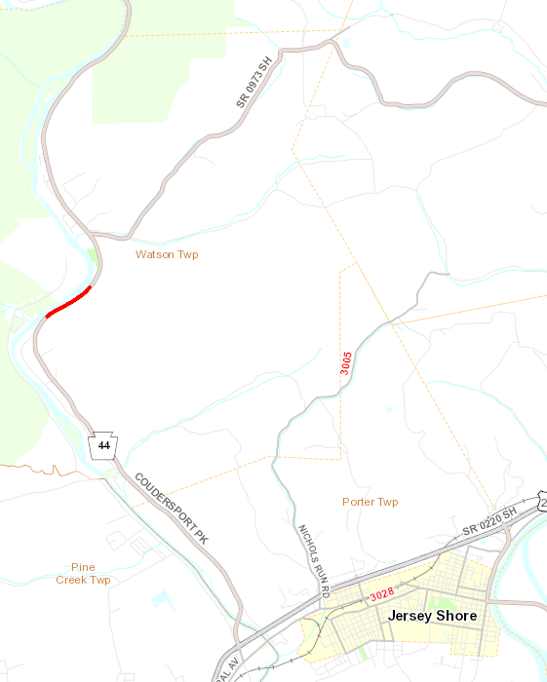

**SR 44-86S Watson Twp. (PennDOT Project)**

**SR 973**

**SR 44**